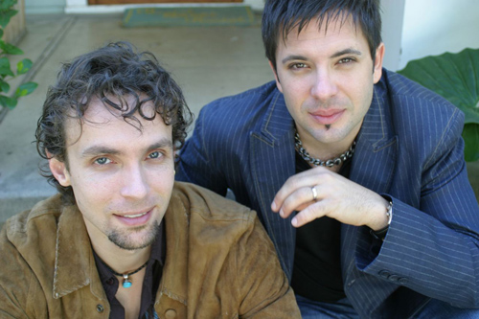


Naked Rhythm



“Music Without Borders”

NAKED RHYTHM was born in Los Angeles in 2003 as a collaborative effort between Avi Sills and Alex Spurkel with a vision of breaking down borders and bringing the world together with cross-cultural music and dance. By seamlessly fusing exotic world music and percussion with contemporary electronic dance grooves, Naked Rhythm captivates Western audiences with the universal language of rhythm and sounds of the Middle-East, India, Africa, and South America. The result is an innovative and organic form of World electronica that moves the heart as well as the hips. Their debut album Frequency was released world-wide in July 2006 by Caravan Records, and their tracks have already been featured on 8 compilations including Tantra Lounge vol 3 & 4 and the upcoming Buddha Bar vol 9. Their captivating live shows featuring numerous world musicians, dancers, and visuals have entertained such stars as Sting, Robert Downey Jr., Dianna Ross, and The Black Eyed Peas.
Alex Spurkel, a diverse producer and percussionist, has toured the world as a cutting-edge electronic/world drummer for acclaimed electronica pioneers, Electric Skychurch. Alex has a solid background in World music and studied ethno-musicology at UCLA, as well as with numerous world-renowned masters. He is also an award-winning producer/composer and released his own sample library CD entitled Electro-World Percussion with Sony Digital Media.

Avi Sills is a dynamic and inspiring drummer/producer. Avi has toured the world as the drummer for numerous artists, and studied at the prestigious Berklee College Of Music. His diverse list of credits include Bob Dylan, Robert Cray, Red Elvises, and Adam Sandler; Film/TV: Six String Samurai, Oprah Winfrey, Melrose Place, Penn & Teller, and many more. Avi works regularly as a composer and partner in music production house Fuel Music And Sound.

“A great musical journey and a huge thank you!” – Sting

“I loved the music, Naked Rhythm made my party.” – Robert Downey Jr.

“You are helping build a vision of World Spirit!” – Alex Grey

