Entertainment Options - SUMMARY

(Photos and detailed descriptions on following pages)

Naked Rhythm – Basic World electronica/dance package (secondary or dance band)
- 4 piece band, 1 dancer
- Two 20 minute sets

World Orchestra – Main band, World fusion
- Two 45 minute sets
- 10-piece band -or-
- 7-piece band

Exotic Lounge Band – Cocktail hour / ambience band
- 5-piece band
- One 45-60 minute set

Dancer/Performer
- Two sets

VJ (Live visuals)
- 4 hour block

DJ (World beat, house/eclectic, or mainstream hits)
- 4 hour block (2-3 sets)

One World Experience package
- World Orchestra (10-piece)
- Exotic Lounge Band
- Naked Rhythm electronica band
- 6 dancers
- VJ
- DJ
- Sample timeline on last page

Photos & full descriptions on following pages.

Entertainment Options - DETAIL

Naked Rhythm – Basic package (dance band or secondary band)
Naked Rhythm presents an innovative form of transglobal electronic dance music. Fusing exotic sounds of the Middle-East, India, and Brazil with contemporary house music and lounge, Naked Rhythm exhilarates audiences and rocks the dance floor with infectious grooves and a splash of culture. A beautiful dancer provides an exciting visual component.

- 4-piece band
  - Vocals & violin/guitar (male or female)
  - Flute, sax, and Eastern woodwinds
  - 2 World percussionist
  - Laptop for backing tracks
- 1 Belly Dancer (can substitute Indian or other dancer)

>Play two 20 minute sets or one 45 minute set. Dancer dances 2 times (5min each).

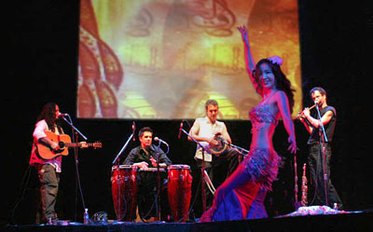
Note: photo includes VJ projections not included in this package.

Hear the music: www.nakedrhythm.com and www.nakedrhythm.com/audio.html
See Video: www.nakedrhythm.com/video.html (select video #2 and video #1)

NR World Orchestra (main band for dinner & dancing)
The Naked Rhythm World Orchestra plays an elegant blend of exotic world music with a Western appeal and a contemporary sound. The band blends Latin, Middle-Eastern, and Indian music with funk, pop, lounge and jazz for a sophisticated sound that represents the far corners of the globe. The energy can range from loungey cocktail music to spicy uptempo dance numbers, and the band always creates a vibe that is both special and unique. This one-of-a-kind lineup routinely rocks the house with primarily original music and a few western and non-western covers thrown in—World Orchestra style! It’s the perfect choice for creating memorable events for a globalized World.
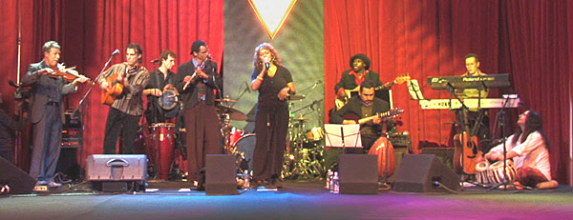

Videos: http://www.nakedrhythm.com/los-angeles-entertainment-booking.html (top left)

The World Orchestra plays in two configurations, 10-piece and 7-piece, described below
- 10-piece World Orchestra, typical lineup
  - Male vocal (English, Arabic, Sanskrit, French, Spanish) & acoustic guitar, and tables (Indian drums)
  - Female vocal (English, Hindi/Indian, Portuguese)
    - -OR- Female vocal (English, Arabic, Hebrew, French)
  - Electric & Nylon string guitar
  - Keyboards
  - Violin
  - Flute, sax, and Eastern woodwinds
  - Oud (Arabic lute) and Sitar (Indian lute)
  - Electric bass
  - World percussion (Latin congas, Middle-Eastern doumbek, African djembe, misc. percussion)
  - Drum kit

>Play two 45 minute sets.

- 7-piece World Orchestra, typical lineup
  - Male vocal (English, Arabic, Sanskrit, French, Spanish) & acoustic guitar
    - -OR- Female vocal (English, Hindi/Indian, Portuguese)
    - -OR- Female vocal (English, Arabic, Hebrew, French)
  - Keyboards
  - Flute, sax, and Eastern woodwinds
  - Oud (Arabic lute) and Sitar (Indian lute)
  - Electric bass
  - World percussion (Latin congas, Middle-Eastern doumbek, African djembe, other percussion)
  - Drum kit

>Play two 45 minute sets.

World Orchestra plays two 45 minute sets. Package includes sound engineer.

NR Exotic Lounge Band (cocktail hour)
Imagine entering a room and the air being filled with lush ambient strings, soothing bamboo flutes, and ethereal eastern vocals. The Naked Rhythm Exotic Lounge band is a superb choice for creating exotic middle and far eastern ambience during cocktail hour or any time beautiful background music is needed. The band plays of blend of Indian, Middle-Eastern, and Far-Eastern textures woven into a beautiful acoustic tapestry, and has the option of playing amplified or all-acoustic. Can also play all Middle-Eastern music for Moroccan or Arabian themed events.

- 5-piece band, typical lineup
  - Male vocal (Arabic, Sanskrit/Indian) & Indian tabla drums
  - Keyboards (or substitute acoustic instrument)
  - Flute, sax, and Eastern woodwinds
  - Oud (Arabic lute) and Sitar (Indian lute)
  - World percussion (Middle-Eastern doumbek, Cajon, other percussion)

> Play one 45-60 minute set

Photos, Video & Audio: Coming soon!

Dancer/Performer
Our hand-picked dancers are all highly specialized, extremely talented, and stunningly beautiful. Representing traditions from around the World as well as hybrid and unique styles, they always leave their audience wowed and mesmerized. Note that certain performers are versed in more than one style.
- Different styles, traditions, and talents
  - Belly dancing
  - Indian classical and fusion dance
  - Sword/martial arts/Asian belly dance fusion
  - Samba/Brazilian dance
  - Cirque hoop dance
  - Flamenco dance
  - Fire Spinning
  - Stilt Walking & Dancing
  - Drummers (World/Tribal)

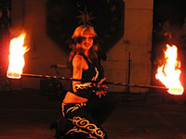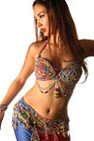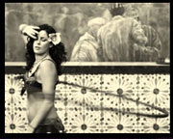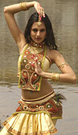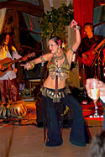

> Dancer performs twice, sets range from 5-10 minutes each. (Stilt walkers and drummers can also be ambient entertainment for up to 1 hour)

VJ (Live Visual Projectionist)
Let one of our VJs add visual magic to your event. The VJ can setup screens in strategic locations or utilize existing screens by plugging his feed into the existing video console. The live video can include such elements as custom picked thematic images, nature scenes, kaleidoscopic effects, photo stills, live camera feeds, and more.

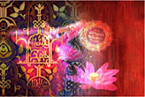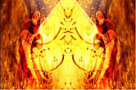

> Projects for 4-hour block

DJ
Our DJs represent the best in their field and are selected to be compatible with the rest of the World entertainment we offer. We offer several different styles for a client’s needs.
- World beat, international
- Eclectic house and hip underground dance
- Popular hits and standards (40’s, 50’s, 60’s, 70’s, 80’s, 90’s, current)

> Play for 4-hour block (2-3 sets)

One World Experience package
This turn-key multi-media entertainment experience will cover all of your event’s entertainment needs from beginning to end, creating a harmonious transglobal experience that the guests will never forget. Included are all of the major components listed above put together in a coherent and synergistic flow that will create the most impressive and memorable impact possible. If you truly want to impress your guests, give them the One World Experience!
Package includes:
- World Orchestra (10-piece), main band
- Exotic Lounge Band, cocktail hour/reception
- Naked Rhythm electronica band, dancing
- 6 dancers - specific dancers may vary depending on availability and needs. Here is a typical lineup:
  - 2 belly dancers
  - Indian classical dancer
  - Cirque hoop dancer
  - 2 samba dancers or 2 fire dancers (if permitted)
- VJ (with screen & projectors if needed)
- DJ (with turntables & mixer if needed)
- Sound engineer, 3-4 crew

Video: http://www.nakedrhythm.com/los-angeles-entertainment-booking.html (left video #2)

Event Timeline – see next page

One World Experience: 6-hour Corporate Event Timeline (sample)*

6:00 – 7:00 Cocktail hour
    - DJ plays ambient music as first guests arrive (15 minutes)
    - Exotic Lounge Band plays, sets the mood (45 minutes)
    - 2 dancers perform one set each as teaser during band’s set
7:00 – 7:30 Guests enter main room
    - 2 drummers round up guests and lead them into the main room to sit down for dinner
7:30 – 8:00 Begin serving appetizers
    - DJ plays light background music
8:00 – 8:45 Main Course – World Orchestra with dinner show
    - World Orchestra plays first set of smooth downtempo music
    - 1 belly dancer performs one song with the band
8:45 – 9:00 Dessert – Show continues while band takes break
    - DJ plays music for dancers
    - Belly dance set
    - Indian dance set
    - Cirque hoop dance set
9:00 – 9:15 Guests get coffee, drinks, bathroom break, etc.
    - DJ spins mid-tempo dance music
9:15 – 10:00 Dance & party time (till end)
    - World Orchestra plays set #2, uptempo dance music
10:00 – 10:15 Finale Show
    - Fire spinners (fire eating, fire fans, poi, and fire hoop)
10:15 – 10:40 DJ spins high-energy dance music
10:40 – 11:00 Dancing continues...
    - Naked Rhythm plays World-electronica dance set
    - Sayaka performs 5-minute sword dance during set
11:00 – 11:45 DJ spins high-energy dance music
11:45 – 12:00 DJ brings it down to mellow mood music, signaling the end of the evening as guests leave

* This is only one possible timeline. We work closely with event organizers to create a customized and optimal timeline for each event. Specific performances and times may vary.

