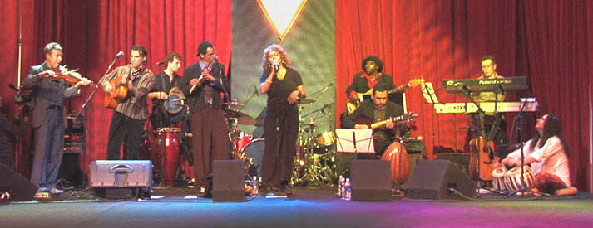

Naked Rhythm



Entertainment, Inc.

“Bringing The World Together With Music And Dance”

NAKED RHYTHM ENTERTAINMENT provides exclusive transglobal entertainment for high-end private and corporate events. Born in Los Angeles in 2003, co-founders Avi Sills and Alex Spurkel began with a vision of uniting people around the globe with multi-cultural music and dance. The heart and soul of the company is Avi and Alex’s band Naked Rhythm, which seamlessly fuses exotic world music with contemporary popular styles to captivate both Western and Eastern audiences. The music integrates lounge, jazz, pop, and electronica with sounds of the Middle-East, India, Africa, Latin and South America. The result is worldly and sophisticated and perfect for events seeking a cultured and globally diverse atmosphere. Our satisfied clients include Sting, Amgen, Robert Downey Jr, and Guess Inc.

Naked Rhythm Entertainment also incorporates beautiful dancers representing ethnic styles from around the world including belly dance, samba, classical Indian, fire spinning, flamenco and more. We also utilize live VJs for stunning visuals and hand-picked World groove DJs to round out the experience. Our roster is steadily expanding to include other World music bands from flamenco to rai, and with our impressive list of talented multinational musicians we are able to provide a band for almost any specific cultural style.

At Naked Rhythm Entertainment we are in the business of creating one-of-a-kind experiences. Let us help create one for you.

Complete online promotional package with videos available at: www.nakedrhythm.com/events

“A great musical journey.” – Sting

“Thank you for providing such stellar entertainment. You made the event memorable and exciting, but overall, unique.” – Guess, Inc.

“I loved the music, Naked Rhythm made my party.” – Robert Downey Jr.

